**HOTEL RESERVATION SYSTEM**

Software Requirements Specification Document

**Team Members:**

Mücahit Tozal: Developer (Team Leader)

Doğan Özbayrak: Developer

Emre Ulusoy: Analyst

Ferhat Erduran: Designer/Database

Uğur Eren Temel: Tester

**TABLE OF CONTENTS**

1. Introduction
   1. Purpose
   2. Document Conventions
   3. Problem Definition and Project Scope
   4. References
2. Overall Description

2.1. User Scenarios

2.2. User Characteristics

2.3. Use Case Diagram

1. Specific Requirements
   1. Functional Requirements
   2. Non-functional Requirements
   3. Object Oriented Models

**INTRODUCTION**

**1.1. Purpose**

The Software Requirements Specification (SRS) document will provide detailed descriptions of the functions, requirements, and constraints of the Hotel Reservation System. The document will act as a guideline for the developers to design, implement, and test the system according to the end users’ needs. It will also provide a general structure of the system for the client to approve. We aim to create a high quality, easy-to-use system for guests and staff alike since it will give the guests their first impression of the hotel.

**1.2. Document Conventions**

This SRS document has been prepared in accordance with the *IEEE Recommended Practice for Software Requirements Specifications (IEEE 830-1998 Standard).*

**1.3 Problem Definition and Project Scope**

Without an online reservation system, the business for a hotel would significantly drop. Therefore, this Hotel Reservation System is being developed for customers to be able to book rooms online. The system will be an online web site that displays general information about the hotel, the types of rooms and their properties, and allows the customer to make a reservation. The system will also allow system admins to view and manage these reservations.

**1.4 References**

[1] Ian Somerville, *Software Engineering*, Pearson (9th Edition, 2010).

[2] Sri Lanka Institute of Information Technology, *Hotel Management System SRS Document Information Technology Project 2014* (Project ID ITP-14-MTR-03). <http://www.academia.edu/10313728/srs_document_for_hotel_management_system>

**OVERALL DESCRIPTION**

**2.1. User Scenarios**

**2.1.1. For the customer:**

**2.1.1.1.** The customer shall open a web browser and go to the Reservation Website.

**2.1.1.2.** The customer shall browse the rooms, deciding which one(s) they may wish to stay in.

**2.1.1.3.** The customer shall click “Make Reservation” and will be redirected to the reservation page.

**2.1.1.4.** The customer shall fill the necessary fields and submit.

**2.1.1.5.** If all fields are filled correctly (as will be presented in *Functional Requirements* in detail) the system shall ask for the customer’s credit card information.

**2.1.1.6.** The customer shall provide the information and confirm.

**2.1.1.7.** If the information is validated successfully, the system shall display a completion message to notify the customer and the reservation will be complete.

**2.1.2. For the admin:**

**2.1.2.1.** The admin shall open a web browser and go to the Reservation Website.

**2.1.2.2.** The admin shall enter his/her account information and log in.

**2.1.2.3.** The system shall display options to manage rooms, current reservations and payments.

**2.1.2.4.** The admin shall be able to see which rooms are currently in use, who is staying there, and update them.

**2.1.2.5.** The admin shall be able to see successful reservations, related information, and update them.

**2.1.2.6.** The admin shall log out.

**2.2. User Characteristics**

The system shall be used by hotel customers and admins. To operate in the system, the users shall need a working internet connection and a basic knowledge of computers. Otherwise, the users do not need to be proficient; the system shall be designed in a way as to make transactions understandable, fast, and easy. The same shall apply to the management of the system for the admins.

**2.3. Use Case Diagram**

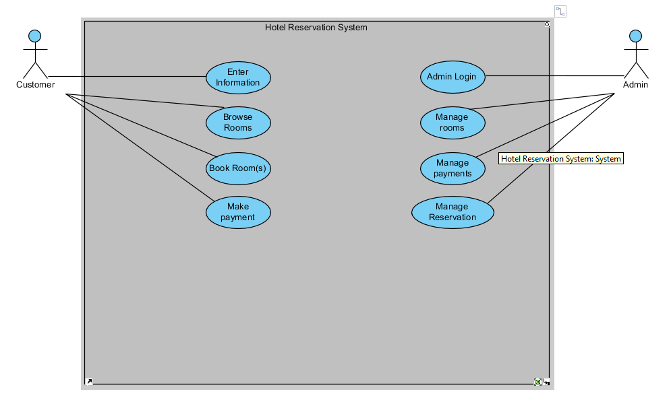

**SPECIFIC REQUIREMENTS**

**3.1. Functional Requirements**

**3.1.1.** The system shall display the home page.

**3.1.2.** The system shall allow the customer to check the different types of rooms, displaying their properties, pictures and the standard payments for each.

**3.1.3.** The system shall inform the customer if any type of room is currently unavailable.

**3.1.4.** After the customer clicks “Make Reservation”, the customer will be redirected to the reservation page.

**3.1.5.** The system shall display the necessary fields (first name, last name, date of birth, phone number, e-mail address, desired type of rooms, number of rooms, number of customers, check-in/check-out dates, additional wishes) for the customer to fill.

**3.1.6.** If any of the fields are not filled properly or are left empty, the system shall ask the customer to fill them again.

**3.1.7.** If all the fields are filled correctly, the system shall accept the reservation and ask for the customer’s credit card information.

**3.1.8.** The system shall validate the information and ask for the customer’s confirmation before accepting the payment.

**3.1.9.** If the transaction is confirmed, the system shall accept and go through with the payment.

**3.1.10.** The system shall inform the user that their reservation is complete.

**3.1.11.** The system shall store all aforementioned data (user and payment information) in the database.

**3.1.12.** The system shall mail the reservation information to the user.

**3.1.13.** The system shall allow the admins to create an account.

**3.1.14.** The system shall allow the admins to login.

**3.1.15.** The system shall allow the admins to manage rooms, reservations and payments.

**3.2) Nonfunctional requirements**

**3.2.1. Recoverability:** The system shall back up its database regularly (every 3 hours) to be able to recover easily from any kind of issues.

**3.2.2. System Availability:** The system shall be designed in such a way that it is available 24/7 and it should not undergo any downtime due to the heavy traffic of the web users.

**3.2.3. General Performances:** The system shall not have more than 5 seconds of delay.

**3.2.4. Security:** The system shall be secured from outside attacks and unauthorized access, and shall be protected from all outside premises.

**3.2.5. Capacity:** The system shall support up to 200 people at one time.

**3.3) Object Oriented Models**

**3.3.1. Class Diagram**

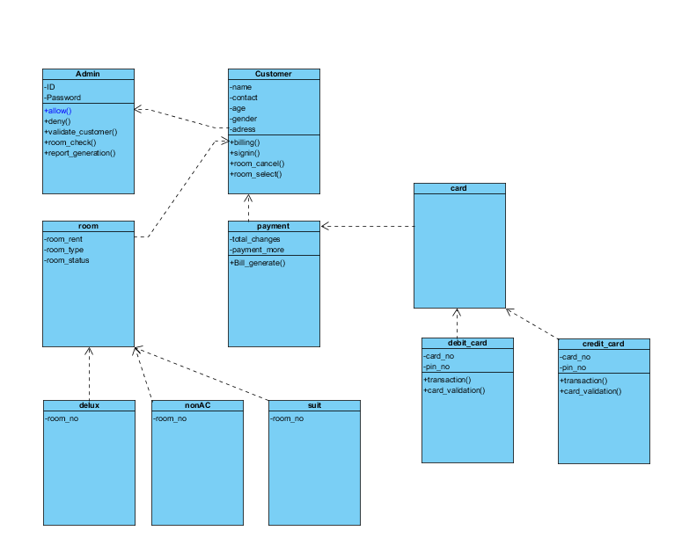

**3.3.2. Activity Diagram**

